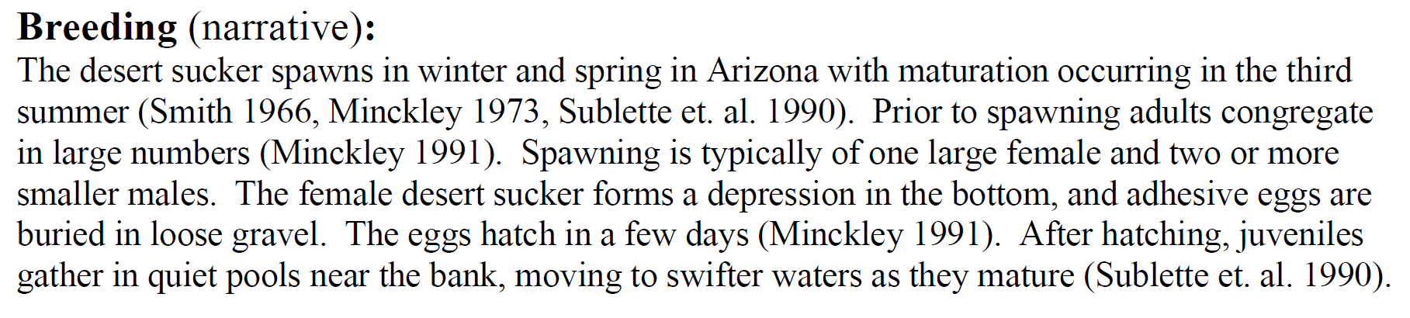

FS Records- Rinne, J.N. and Magaña, H.A.

